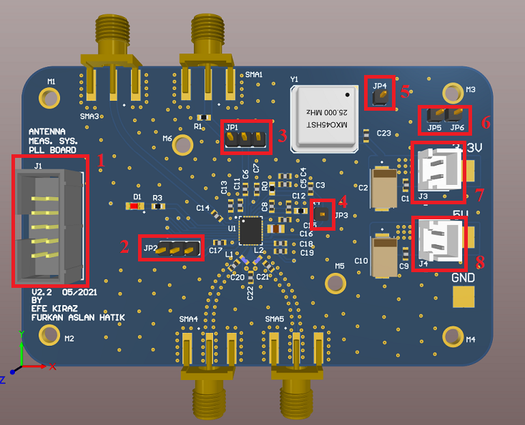**FREQUENCY SYNTHESIZER (PLL) BOARD PINOUT**

Figure 1 : Frequency synthesizer board connectors at the inside of the box

|  |  |  |  |  |  |  |  |  |  |  |  |  |  |  |  |  |  |  |  |  |  |  |
| --- | --- | --- | --- | --- | --- | --- | --- | --- | --- | --- | --- | --- | --- | --- | --- | --- | --- | --- | --- | --- | --- | --- |
|  |  |  |  |  |  |  |  |  |  |  |  |  |  |  |  |  |  |  |  |  |  |  |
|  |  |  |  |  |  |  |  |  |  |  |  |  |  |  |  | 18 |  |  |  |  |  |  |
|  |  |  |  |  |  |  |  |  |  |  |  |  |  |  |  |  |  |  | 19 | 20 |  |  |
|  |  |  |  |  |  |  |  |  |  |  |  |  |  |  |  |  |  |  |  |  |  |  |
|  |  |  |  |  |  |  |  |  | 14 | 15 | 16 |  |  |  |  |  |  |  |  |  |  |  |
|  |  |  |  |  |  |  |  |  |  |  |  |  |  |  |  |  |  |  |  |  |  |  |
|  | 1 | 2 |  |  |  |  |  |  |  |  |  |  |  |  |  |  |  |  | 21 |  |  |  |
|  | 3 | 4 |  |  |  |  |  |  |  |  |  |  |  |  |  |  |  |  | 22 |  |  |  |
|  | 5 | 6 |  |  |  |  |  |  |  |  |  |  |  | 17 |  |  |  |  |  |  |  |  |
|  | 7 | 8 |  |  | 11 | 12 | 13 |  |  |  |  |  |  |  |  |  |  |  | 23 |  |  |  |
|  | 9 | 10 |  |  |  |  |  |  |  |  |  |  |  |  |  |  |  |  | 24 |  |  |  |
|  |  |  |  |  |  |  |  |  |  |  |  |  |  |  |  |  |  |  |  |  |  |  |

|  |  |  |  |
| --- | --- | --- | --- |
| Pin Number | Pin Name | Pin Number | Pin Name |
| 1 | GND | 13 | 3.3V |
| 2 | STAT | 14 | REF-EX |
| 3 | GND | 15 | REF+ |
| 4 | CS’ | 16 | REF-IN |
| 5 | GND | 17 | CP |
| 6 | SCLK | 18 | REF-IN |
| 7 | GND | 19 | GND |
| 8 | SDI | 20 | GND |
| 9 | GND | 21 | GND |
| 10 | SDO | 22 | 3.3V |
| 11 | GND | 23 | GND |
| 12 | MUTE’ | 24 | 5V |